# 

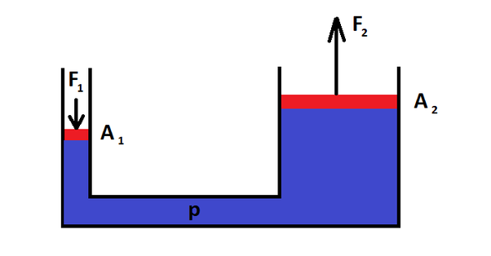

Since we have: $F_{2}=P=mg=2000×9.8=19600 (N)$

Pascal’s principle:

$$\frac{F_{1}}{A_{1}}=\frac{F_{2}}{A_{2}}→F_{1}=\frac{F_{2}A_{1}}{A_{2}}=\frac{F_{2}\left({πd_{1}^{2}}/4\right)}{{πd_{2}^{2}}/4}=\frac{d_{1}^{2}F_{2}}{d_{2}^{2}}=\frac{2^{2}×19600}{{24}^{2}}=136.11 \left(N\right)$$

Equation of continuity:

$$A_{1}v_{1}=A_{2}v_{2}→v_{2}=\frac{A_{1}v_{1}}{A_{2}}=\frac{π×2^{2}×0.5}{π×1^{2}}=2 (m/s)$$

Bernoulli’s equation:

$$p_{1}+\frac{1}{2}ρv_{1}^{2}+ρgh_{1}=p_{2}+\frac{1}{2}ρv_{2}^{2}+ρgh_{2}$$

$$↔3×{10}^{5}+\frac{1}{2}×1000×{0.5}^{2}+0=p_{2}+\frac{1}{2}×1000×2^{2}+1000×9.8×5$$

$$→p_{2}=2.49×{10}^{5} \left(Pa\right)$$

Given that: $α=14.2×{10}^{-6} \left(K^{-1}\right)→β=3α=42.6×{10}^{-6} \left(K^{-1}\right)$

We have:

$$ρ_{0}=\frac{m}{V_{0}}$$

$$→ρ=\frac{m}{V}=\frac{m}{V_{0}(1+β∆T)}=\frac{ρ_{0}}{1+β∆T}=\frac{19.3}{1+42.6×{10}^{-6}(90-20)}=19.24 \left(g/{{cm}^{3}}\right)$$

$T_{M}:$ temperature at the point which is 20 cm from the hot end $\left(L_{1}\right)$

$$P_{cond}=kA\frac{T_{H}-T_{L}}{L}=kA\frac{T_{H}-T_{M}}{L_{1}}$$

$$→\frac{100-40}{60}=\frac{100-T_{M}}{20}→T_{M}=80 \left(℃\right)$$

Given that: $Q_{AB}=150 \left(J\right);Q_{BD}=600 \left(J\right)$

$$W_{ABD}=W_{AB}+W_{BD}=0+80×\left(0.005-0.002\right)×{10}^{3}=240 \left(J\right)$$

$$→∆E_{ACD}=∆E_{ABD}=Q_{ABD}-W_{ABD}=\left(150+600\right)-240=510 (J)$$

$$W_{ACD}=W_{AC}+W_{CD}=30×\left(0.005-0.002\right)×{10}^{3}+0=90 \left(J\right)$$

$$→Q_{ACD}=∆E_{ACD}+W_{ACD}=510+90=600 (J)$$